Logistic Regression

1) Why Logistic Regression?
Linear Regression predicts continuous outputs (e.g., house prices).
But what if we need to predict categories, like:
- Will the customer churn? (Yes/No)
- Is the email spam? (Spam/Not Spam)
We need the output to be between 0 and 1, representing a probability.

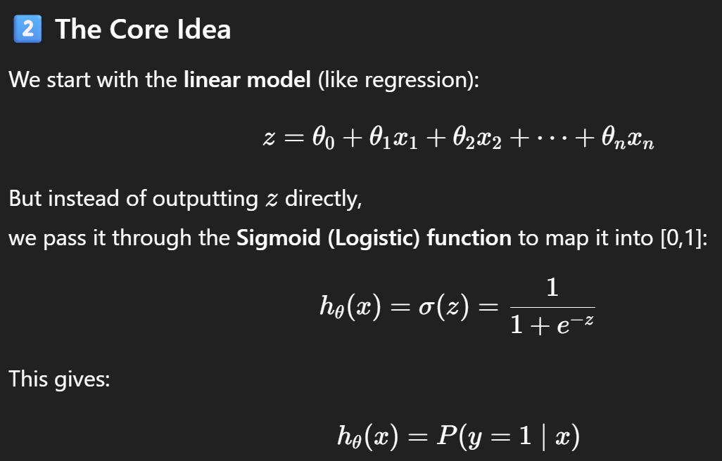
Property | Description
Output range | (0, 1)
S-shape | Grows smoothly from 0 → 1
Threshold | At z=0 → output = 0.5
Interpretation | Probability of positive class

3) Cost Function (Why not MSE?)
If we use MSE, the curve is non-convex (hard to optimize).
So we use Log Loss (Cross-Entropy Loss), derived from maximum likelihood estimation.
$$J(θ)=-\frac{1}{m}\sum_{i=1}^{m}{}[y_{i}log⁡(h_{θ}(x_{i}))+(1-y_{i})log⁡(1-h_{θ}(x_{i}))]$$
- Penalizes confident wrong predictions heavily.
- Convex → guaranteed single global minimum.

Intuition:
- If actual y=1 → cost = -log(predicted probability)
- If actual y=0 → cost = -log(1 - predicted probability)
✅ Model tries to maximize likelihood of correct labels → equivalent to minimizing log loss.

4) Gradient Descent in Logistic Regression
The cost function is differentiable → we can use Gradient Descent.
For each parameter $θ_{j}$:
$$\frac{∂J(θ)}{∂θ_{j}}=\frac{1}{m}\sum_{i=1}^{m}{}(h_{θ}(x_{i})-y_{i})x_{ij}$$
Then update:
$$θ_{j}:=θ_{j}-α\frac{∂J(θ)}{∂θ_{j}}$$
Same form as Linear Regression — only difference is $h_{θ}(x)$uses the sigmoid.

5) Regularization
Just like in regression, we can add penalty terms to prevent overfitting:
Ridge (L2) Regularized Logistic Regression:
$$J(θ)=-\frac{1}{m}\sum_{i=1}^{m}{}[y_{i}log⁡(h_{θ}(x_{i}))+(1-y_{i})log⁡(1-h_{θ}(x_{i}))]+\frac{λ}{2m}\sum_{j=1}^{n}{}θ_{j}^{2}$$
Lasso (L1) Regularized Logistic Regression:
$$J(θ)=-\frac{1}{m}\sum_{i=1}^{m}{}[y_{i}log⁡(h_{θ}(x_{i}))+(1-y_{i})log⁡(1-h_{θ}(x_{i}))]+\frac{λ}{m}\sum_{j=1}^{n}{}∣θ_{j}∣$$
- L2 (Ridge) → smooth shrinkage
- L1 (Lasso) → sparse coefficients (feature selection)
In scikit-learn:
from sklearn.linear_model import LogisticRegression
model = LogisticRegression(penalty='l2', C=1/lambda_value)

Metric | Formula / Use | Notes
Accuracy | (TP + TN) / (TP + FP + TN + FN) | Works only for balanced data
Precision | TP / (TP + FP) | Reliability of positive predictions
Recall (Sensitivity) | TP / (TP + FN) | Ability to detect positives
F1 Score | 2 * (Precision * Recall) / (Precision + Recall) | Balance between precision & recall
ROC Curve | Plot of TPR vs FPR | Visual threshold analysis
AUC | Area under ROC | Probability model ranks correctly
Log Loss | Same as cost | Lower = better calibrated probabilities

